LOGO PROCESS
Decoration Type
- Print
- Embroidery

Positions Available
Different positions available depending on product. We can provide this info in a chart of some sort and assign each product a number which references the positions available for each product
- Left Chest
- Right Chest
- Left Arm
- Right Arm
- Rear Nape
- Centre Front (Large)
- Centre Back (Large)
- Centre (hats)
- Left Pocket (Trousers)
- Right Pocket (Trousers)

Logo Application process.
- Once all selected items are in the basket we want to then select the garments we want to personalise and add logos in one go as opposed to adding logos to each garment each time. Eg Poloshirt – add logo, Sweatshirt add logo.
- Examples of this can be found with sites such as workwearexpress.com, essentialworkwear.com and clothes2order.com.
Personalisation – in product basket
STEP 1 – Select the garments you wish to personalise
STEP 2 – Select Logo Location
- This is based on the location options pre-set for each garment mentioned above.
- Customer can choose more than one location for the same garment – EG Left Chest and Right Arm
- Customer may want to have different logo options for different garments, so we need to facilitate this. Eg Poloshirt may be left chest only and the jacket may be left chest and rear.
STEP 3 – Choose Logo Type – 4 options
Logo
- Embroidered Logo
- Printed Logo
Text
- Embroidered Text
- Printed Text

- If NEW Print or Embroidery Logo – Apply one off set up charge of £9.99 + VAT
- If NEW Text logo – Apply a one off set up charge of £4.99 + VAT

STEP 4 – Upload Logo
- If NEW Print or Embroidered Logo
  - Customer uploads logo image
  - We set up logo and send customer an image for their approval
  - Customer see’s logo in admin to approve and we are notified.
- If REPEAT Order Logo – we need a way of having the site allow the customer to retrieve the logo they have used on a previous order to apply it to repeat orders and not charge a set up fee.

- If NEW Text Logo – open 3 text line fields for customer to enter their text or they can have the option to upload an image of their logo.
  - Max’ of 22 characters per line
  - Based on pre-defined font types
See below example from workwear express on text logo set up options
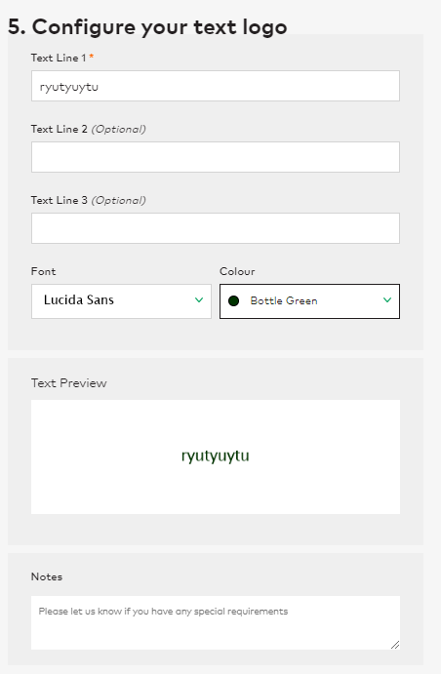

STEP 5 – Add Another Logo? (where the customer adds a 2nd of 3rd logo to the same garment)
- A repeat of the above process
STEP 6 – Add to Basket

